
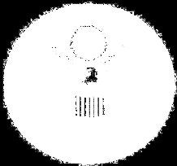

Cambodia
American Corner
Joint project of Management and Economics University and U.S. Embassy Phnom Penh

Rules and Regulations

- Circulation Policy

  - Registration
  - Adhere photo (3 x 4)
  - Check out maximum: 2 books
  - Check out duration: 14 days
  - Could extend: 14 days (only one time, patron who want to extend book have to bring it to library)
  - Check in/out materials before 4:45 PM

    - Reference materials, Periodicals, and Audio Visual Collection are non-circulating.

- Fine Policy

  - One day late: 500R (Maximum up to 40,000R)
  - Over 30 days late: will suspend borrowing privileges for 100 days
  - Damaging plastic cover: 1000R
  - Damaging barcode: 1000R
  - Damaging call number: 1000R
  - Lost book: Must pay for its current replacement cost plus 4000R

- Internet Use Policy
  - One user one hour a day
NOTE:
- Please do not highlight or write on any book.
- Have materials checked before leaving the library.

Thank you for your cooperation and understanding.

